Therapy App using Figma

There are numerous mental health issues prevalent amongst individuals. Individuals facing mental health issues tend to have a low self-esteem, suffer from substance abuse, have communication issues, and health problems, leading to difficult inter-personal relationships. These are just some of the very many consequences of a failing mental health, the most morbid of it being suicide. Often, for the lack of a judgement-free space to voice metal health problems, these issues are not addressed. These problems are relegated to the remote recesses of one's mind. Hence to have an easier access to get in touch with mental health professionals I have designed the Therapy app.

- LOGIN / SIGN-UP SCREEN

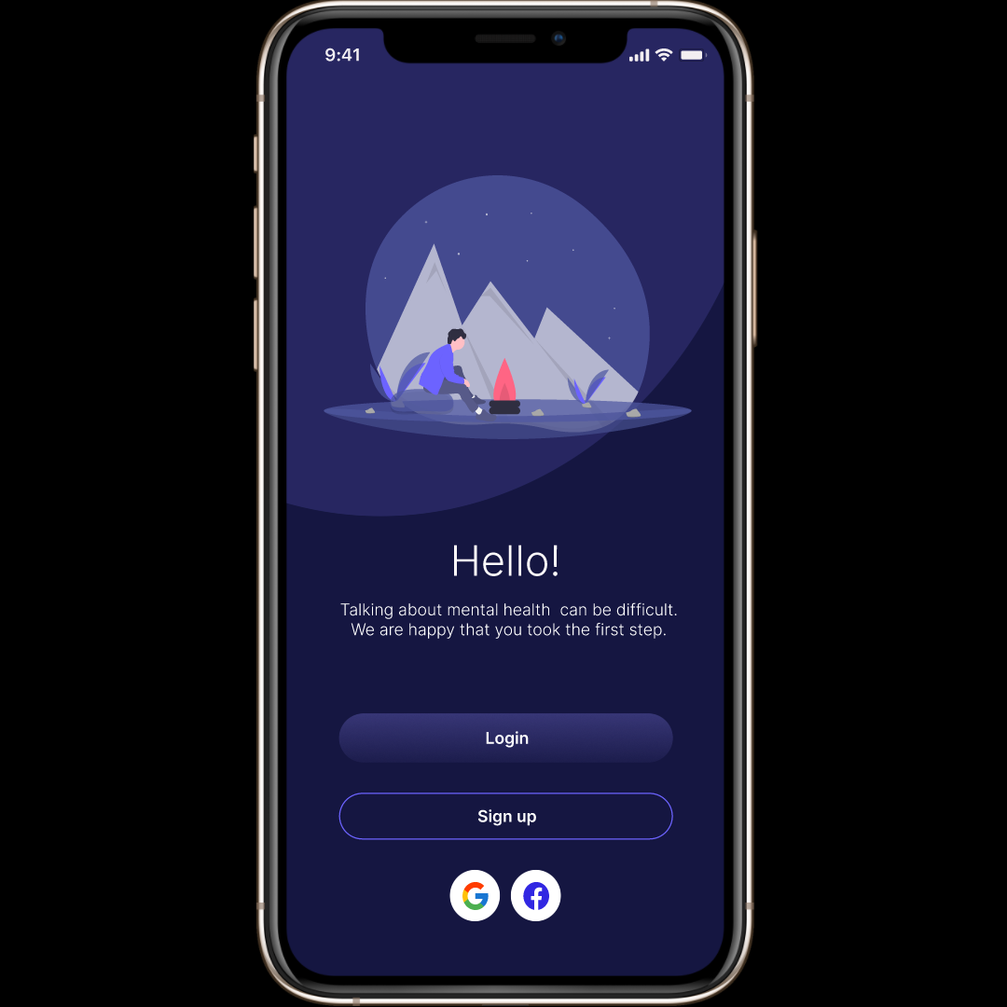

- REMOTE LOGIN SCREEN

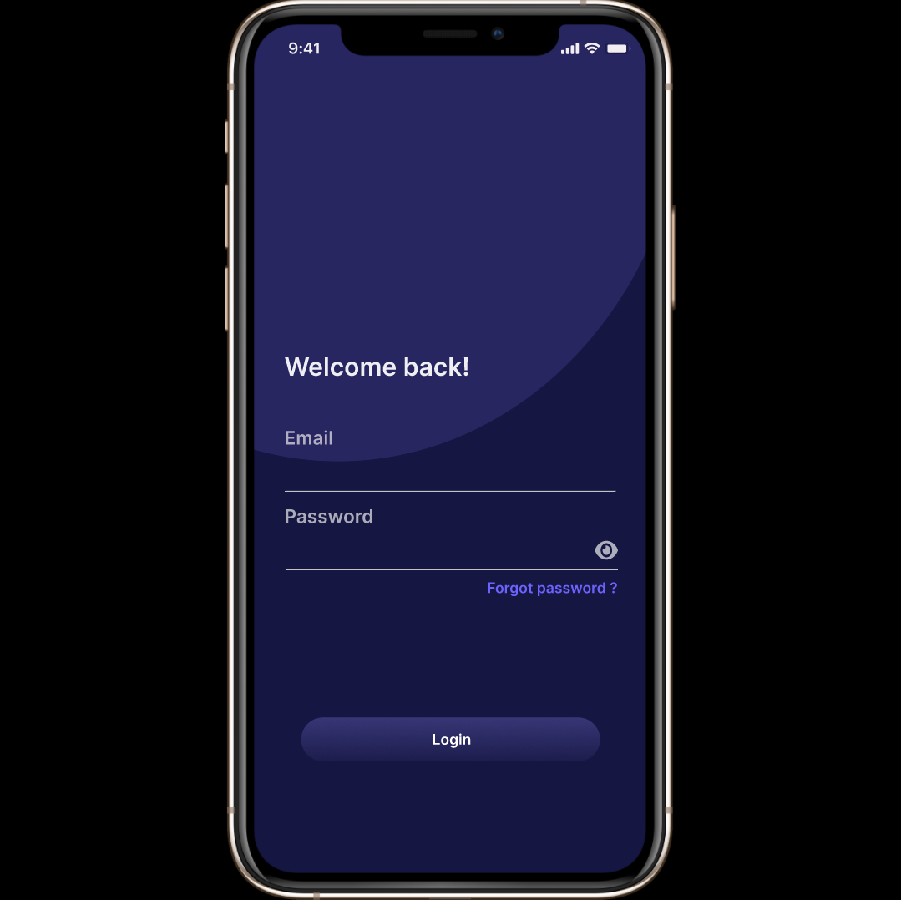

- REMOTE SIGN-UP SCREEN

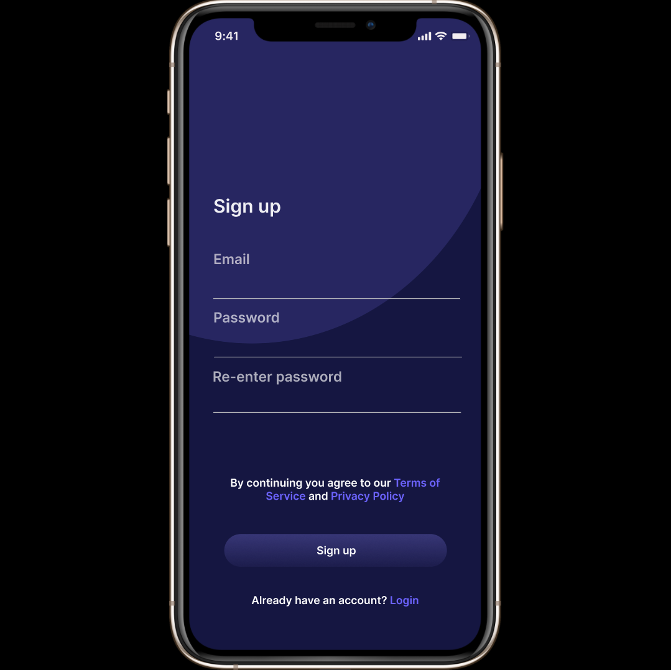

- TYPE OF COUNSELLING PAGE

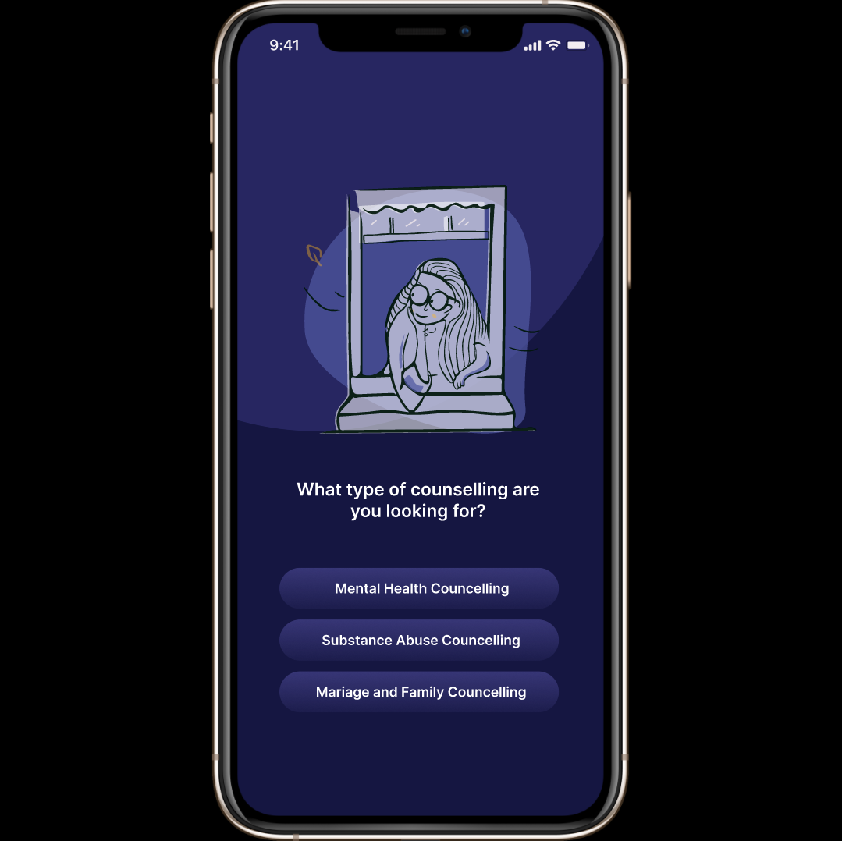

- PERSONAL INSFORMATION

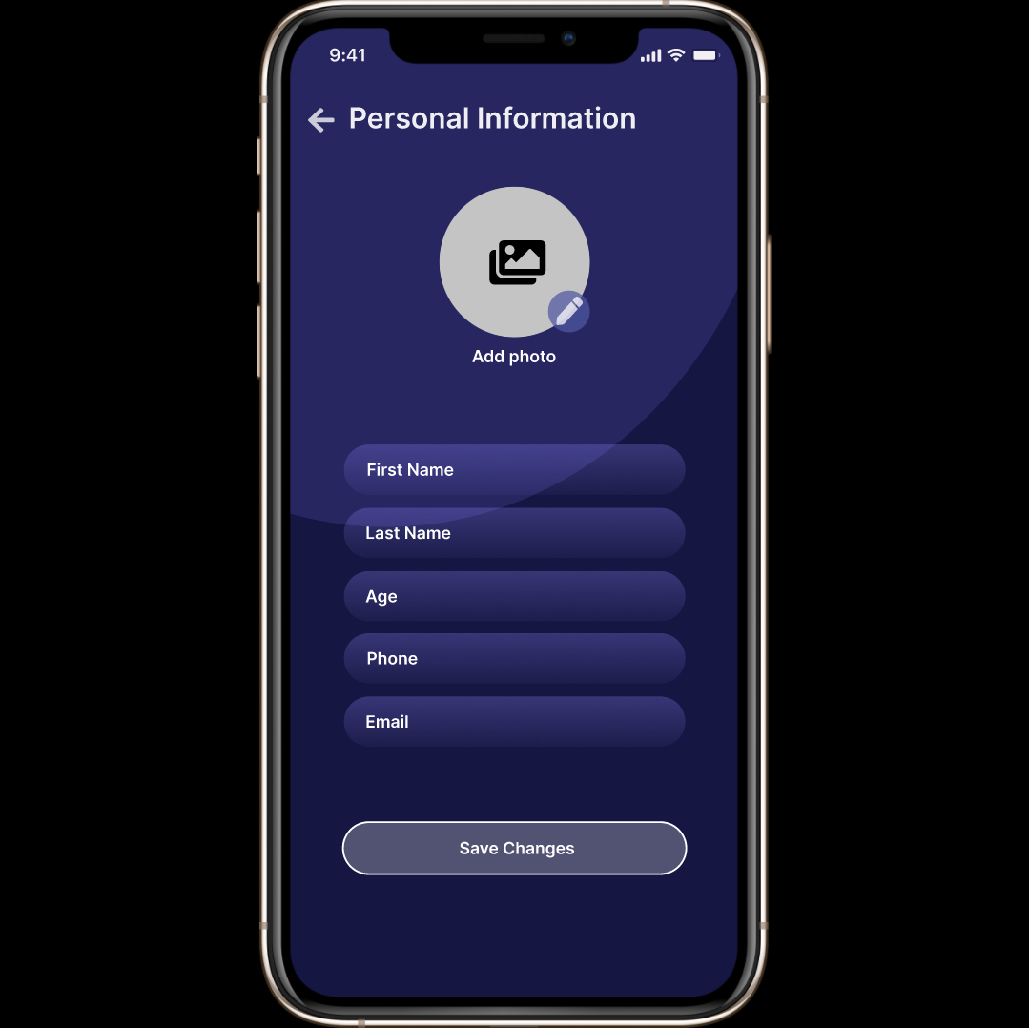

- HOME SCREEN

